EXPERIMENT 6

**AIM:** To verify the functionality of PN junction diode in forward bias and reverse bias.

**OBJECTIVE**: To study Volt-Ampere Characteristics of P-N Diode and also find cut-in voltage for P-N Junction diode.

**THEORY: Operation:** A PN junction diode is formed when a single crystal of semiconductor is doped with acceptors impurities (Pentavalent) on one side and donor impurities (Trivalent) on the other side. It has two terminals called electrodes, one each from P-region and N-region. Due to two electrodes it is called (i.e., Di-electrode) Diode.

**Biasing of PN junction Diode:**

Applying external D.C. voltage to any electronic device is called biasing. There is no current in the unbiased PN junction at equilibrium. Depending upon the polarity of the D.C. voltage externally applied to diode, the biasing is classified as forward biasing and Reverse biasing.

**Forward bias operation:** The P-N junction supports uni-directional current flow. If +ve terminal of the input supply is connected to anode (P-side) and –ve terminal of the input supply is connected the cathode. Then diode is said to be forward biased. In this condition the height of the potential barrier at the junction is lowered by an amount equal to given forward biasing voltage. Both the holes from p-side and electrons from n-side cross the junction simultaneously and constitute a forward current from n-side cross the junction simultaneously and constitute a forward current (injected minority current – due to holes crossing the junction and entering P- side of the diode). Assuming current flowing through the diode to be very large, the diode can be approximated as short- circuited switch.

**Reverse bias operation:** If negative terminal of the input supply is connected to anode (p-side) and –ve terminal of the input supply is connected to cathode (n-side) then the diode is said to be reverse biased. In this condition an amount equal to reverse biasing voltage increases the height of the potential barrier at the junction. Both the holes on P-side and electrons on N-side tend to move away from the junction there by increasing the depleted region. However the process cannot continue indefinitely, thus a small current called reverse saturation current continues to flow in the diode. This current is negligible; the diode can be approximated as an open circuited switch.

**Diode current equation:** The volt-ampere characteristics of a diode explained by the following equations:

http://i.imgur.com/HQOC5uX.gif

I = current flowing in the diode, I0 = reverse saturation current

V = Voltage applied to the diode

VT= volt- equivalent of temperature = k T/q = T/ 11,600 = 26mV (@ room temp)

http://i.imgur.com/sFdxwNw.gif =1 (for Ge) and 2 (for Si). It is observed that Ge diodes has smaller cut-in-voltage when compared to Si diode. The reverse saturation current in Ge diode is larger in magnitude when compared to silicon diode.

**APPARATUS REQUIRED:**

|  |  |  |  |
| --- | --- | --- | --- |
| **S. No.** | **Components/Equipments** | **Quantity** | **Remarks** |
| 1 | Diode (1N4007) | 1 |  |
| 2 | Resistor (1K) | 1 |  |
| 3 | Dual DC Regulated Power supply (0 - 30 V) | 1 |  |
| 4 | Digital Ammeters  ( 0 - 200 mA, 0 - 200 µA) | 1 |  |
| 5 | Digital Voltmeter (0 - 20V) | 1 |  |
| 6 | Connecting wires | 1 |  |
| 7 | Bread board | 1 |  |

**CIRCUIT DIAGRAM:**

**Forward Bias Condition:** Forward Bias Condition is given as

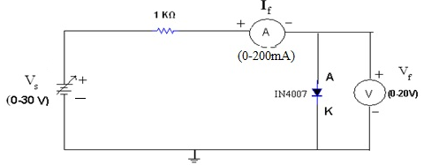

Figure: Forward Bias Connection

**Reversed Bias Condition:** Reversed Bias Condition is given as:

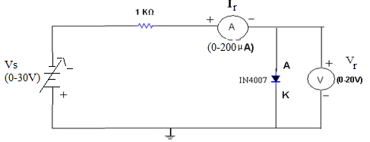

Figure: Reverse Biased Connection

**PROCEDURE: Forward Bias Condition:**

1. Connect the circuit as shown in figure (1) using PN Junction diode.
2. Initially vary Regulated Power Supply (RPS) voltage **Vs** in steps of **0.1 V**. Once the current starts increasing vary **Vs** from **1V** to **12V** in steps of **1V** and note down the corresponding readings **V*f*** and **I*f***.
3. Tabulate different forward currents obtained for different forward voltages.

**Reverse Bias Condition:**

1. Connect the circuit as shown in figure (2) using PN Junction diode.
2. Vary **Vs** in the Regulated Power Supply (RPS) gradually in steps of **1V** from **0V** to **12V** and note down the corresponding readings **V*r*** and **I*r***.
3. Tabulate different reverse currents obtained for different reverse voltages.
4. To get the graph in reverse region (theoretically), remove voltmeter and with reference to the supply voltage note down the reverse current readings in Ammeter because current always selects low reactance path.(Diode have infinite resistance in reverse bias ideally).To get the graph in reverse region (theoretically), replace voltmeter with nano ammeter. Voltmeter has less load resistance when compared to diode. Current conducts in low resistance path.

**OBSERVATIONS: Forward Bias Condition:**

|  |  |  |
| --- | --- | --- |
| **RPS Voltage Vs(volts)** | **Forward Voltage across the diode V*f* (volts)** | **Forward Current through the diode I*f* (mA)** |
| 1 |  |  |
| 2 |  |  |
| 3 |  |  |
| 4 |  |  |
| 5 |  |  |
| 6 |  |  |
| 7 |  |  |
| 8 |  |  |
| 9 |  |  |
| 10 |  |  |

**Reverse Bias Condition:**

|  |  |  |
| --- | --- | --- |
| **RPS Voltage Vs(volts)** | **Reverse Voltage across the diode V*r* (volts)** | **Reverse Current through the diode I*r* (µA)** |
| 1 |  |  |
| 2 |  |  |
| 3 |  |  |
| 4 |  |  |
| 5 |  |  |
| 6 |  |  |
| 7 |  |  |
| 8 |  |  |
| 9 |  |  |
| 10 |  |  |

**Graph:**

1. Take a graph sheet and divide it into 4 equal parts. Mark origin at the center of the graph sheet.
2. Now mark +ve X-axis as V*f*, -ve X-axis as V*r*, +ve Y-axis as I*f* and –ve Y-axis as I*r*.
3. Mark the readings tabulated for Si forward biased condition in first Quadrant and Si reverse biased condition in third Quadrant.

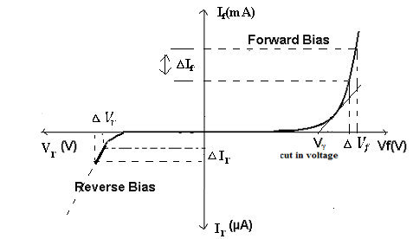

Fig: V- I Characteristics of PN Junction Diode under Forward & Reverse Bias Conditions

**KEY PARAMETERS:**

|  |  |
| --- | --- |
| **List of Parameters** | **SILION DIODE (1N4007)** |
| Maximum Forward Current | 1A |
| Maximum Reverse Current | 5.0µA |
| Maximum Forward Voltage | 0.8V |
| Maximum Reverse Voltage | 1000V |
| Maximum Power Dissipation | 30mW |
| Temperature | -65 to 200° C |

**EXPERIMENT RESULT:**

1. Calculate the ideal voltages and currents for each element in the circuit and compare them to the measured values.
2. Compute the percentage error in the two measurements and provide a brief explanation for the error.
3. Give the explanation regarding the error in terms of different causes etc.
4. Explain the behavior of the graph and why it is so?

**PRECAUTIONS:**

1. While doing the experiment do not exceed the readings of the diode. This may lead to damaging of the diode.
2. Connect voltmeter and ammeter in correct polarities as shown in the circuit diagram.
3. Do not switch ON the power supply unless you have checked the circuit connections as per the circuit diagram.

**QUESTIONS:**

1. What are trivalent and pentavalent impurities?
2. How PN junction diode does acts as a switch?
3. What is diode current equation?
4. What is the value of Vt at room temperature?
5. Dynamic resistance expression?
6. What is a semiconductor?
7. What is meant by intrinsic semiconductor?
8. What is the order of energy gap in a pure semiconductor?
9. What is an extrinsic semiconductor?
10. What is a doped semiconductor?
11. What is doping?
12. What are two different types of impurities?
13. To which group does a (i) p-type, (ii) n type impurity belong?
14. What are the charge carriers in a pure semiconductor?
15. What are the charge carriers in n-type semiconductor?

EXPERIMENT 7

**AIM:** To Plot the V-I Characteristics and verify the functionality the regulation action of Zener diode.

**OBJECTIVE**: To plot the Volt-Ampere Characteristics of Zener Diode and also find Zener Breakdown Voltage in Reverse Biased conditions and observe the regulation action.

**THEORY:**

Zener diodes are a special kind of diode which permits current to flow in the forward direction. What makes them different from other diodes is that Zener diodes will also allow current to flow in the reverse direction when the voltage is above a certain value. This breakdown voltage is known as the Zener voltage. In a standard diode, the Zener voltage is high, and the diode is permanently damaged if a reverse current above that value is allowed to pass through it. Zener diodes are designed in a way where the Zener voltage is a much lower value. There is a controlled breakdown which does not damage the diode when a reverse current above the Zener voltage passes through a Zener diode.

The most common values for nominal working voltage are 5.1 V, 5.6 V, 6.2 V, 12 V and 15 V. We also carry Zener diodes with nominal working voltage up to 1 kV. Forward (drive) current can have a range from 200 uA to 200 A, with the most common forward (drive) current being 10 mA or 200 mA. In the forward bias direction, the zener diode behaves like an ordinary silicon diode.

In the reverse bias direction, there is practically no reverse current flow until the breakdown voltage is reached. When this occurs there is a sharp increase in reverse current. Varying amount of reverse current can pass through the diode without damaging it. The breakdown voltage or zener voltage (VZ) across the diode remains relatively constant. The maximum reverse current is limited, however, by the wattage rating of the diode.

**Avalanche Break down:**

When the diode is in the reverse bias condition, the width of the depletion region is more. If both p-side and n-side of the diode are lightly doped, depletion region at the junction widens. In reverse bias, the minority charge carrier current flows through junction. As the applied reverse voltage increases the minority carriers acquire sufficient energy to collide with the carriers in the covalent bonds inside the depletion region. As a result, the bond breaks and electron hole pairs are generated. The process becomes cumulative and leads to the generation of a large number of charge carriers resulting in Avalanche Breakdown.

**Zener Break down:**

If both p-side and n-side of the diode are heavily doped, depletion region at the junction reduces compared to the width in normal doping. Applying a reverse bias causes a strong electric field get applied across the device. As the reverse bias is increased, the Electric field becomes strong enough to rupture covalent bonds and generate large number of charge carriers. Such sudden increase in the number of charge carriers due to rupture of covalent bonds under the influence of strong electric field is termed as Zener breakdown.

**Zener Diode as Voltage Regulator:**

The function of a regulator is to provide a constant output voltage to a load connected in parallel with it in spite of the ripples in the supply voltage or the variation in the load current and the zener diode will continue to regulate the voltage until the diodes current falls below the minimum IZ(min) value in the reverse breakdown region. It permits current to flow in the forward direction as normal, but will also allow it to flow in the reverse direction when the voltage is above a certain value - the breakdown voltage known as the Zener voltage. The Zener diode specially made to have a reverse voltage breakdown at a specific voltage. Its characteristics are otherwise very similar to common diodes. In breakdown the voltage across the Zener diode is close to constant over a wide range of currents thus making it useful as a shunt voltage regulator.

The purpose of a voltage regulator is to maintain a constant voltage across a load regardless of variations in the applied input voltage and variations in the load current. The resistor is selected so that when the input voltage is at VIN(min) and the load current is at IL(max) that the current through the Zener diode is at least Iz(min). Then for all other combinations of input voltage and load current the Zener diode conducts the excess current thus maintaining a constant voltage across the load. The Zener conducts the least current when the load current is the highest and it conducts the most current when the load current is the lowest.

**APPARATUS REQUIRED:**

|  |  |  |  |
| --- | --- | --- | --- |
| **S. No.** | **Components/Equipments** | **Quantity** | **Remarks** |
| 1 | Zener Diodes (1N4735A) | 1 |  |
| 2 | Resistors (1Khttp://i.imgur.com/6fz6IHX.gif, 3.3http://i.imgur.com/6fz6IHX.gif) | 1 |  |
| 3 | Dual DC Regulated Power supply (0 - 30 V) | 1 |  |
| 4 | Digital Ammeters  ( 0 - 200 mA, 0 - 200 µA) | 1 |  |
| 5 | Digital Voltmeter (0 - 20V) | 1 |  |
| 6 | Connecting wires | 1 |  |
| 7 | Bread board | 1 |  |

**CIRCUIT DIAGRAM:**

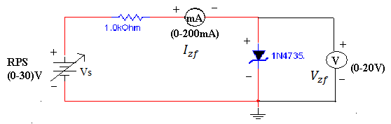 Figure: Forward Bias Condition

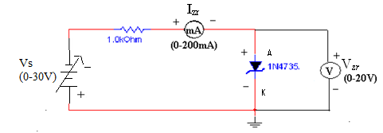

Figure: Reverse Bias Condition

**PROCEDURE: a) Forward Bias Condition:**

1. Connect the circuit as shown in figure (1).
2. Initially vary Vs in steps of 0.1V. Once the current starts increasing vary Vs in steps of 1V up to 12V. Note down the corresponding readings of Vzf and Izf.

**b) Reverse Bias Condition:**

1. Connect the circuit as shown in figure (2).
2. Vary Vsgradually in steps of 1V up to 12V and note down the corresponding readings of Vzr and I*zr*.
3. Tabulate different reverse currents obtained for different reverse voltages.

**OBSERVATIONS:**

**Table: 1 Forward Bias Condition:**

|  |  |  |
| --- | --- | --- |
| **RPS Voltage Vs(volts)** | **Forward Voltage across the diode V*zf* (volts)** | **Forward Current through the diode I*zf* (mA)** |
|  |  |  |
|  |  |  |
|  |  |  |
|  |  |  |
|  |  |  |
|  |  |  |

**Table: 2 Reverse Bias Condition:**

|  |  |  |
| --- | --- | --- |
| **RPS Voltage Vs(volts)** | **Reverse Voltage across the diode V*zr*(volts)** | **Reverse Current through the diode I*zr*(mA)** |
|  |  |  |
|  |  |  |
|  |  |  |
|  |  |  |
|  |  |  |

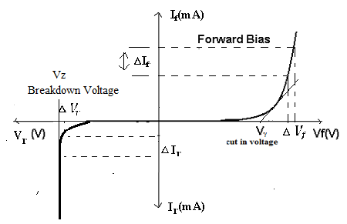

Fig: V- I Characteristics of Zener Diode under Forward & Reverse Bias Conditions

**KEY PARAMETERS:**

* Breakdown Voltage = 5.1V
* Power dissipation = 0.75W
* Max Forward Current = 1A

**EXPERIMENT RESULT:**

1. Calculate the ideal voltages and currents for each element in the circuit and compare them to the measured values.
2. Compute the percentage error in the two measurements and provide a brief explanation for the error.
3. Give the explanation regarding the error in terms of different causes etc.
4. Explain the behavior of the graph and why it is so?

**PRECAUTIONS:**

1. While doing the experiment do not exceed the readings of the diode. This may lead to damaging of the diode.
2. Connect voltmeter and ammeter in correct polarities as shown in the circuit diagram.
3. Do not switch ON the power supply unless you have checked the circuit connections as per the circuit diagram.

**QUESTIONS:**

1. What is the doping concentration in Zener diodes?
2. Can we use Zener diode as a switch?
3. What is PIV of Zener?
4. What will happen if P-N regions are heavily doped in Zener diode?
5. List the other Zener diodes with different breakdown voltages.
6. Is the breakdown region in Zener really destructible?
7. What is a Zener diode?
8. How the name of the Zener came?
9. What is cause of reverse breakdown?
10. What is Zener voltage?
11. What are trivalent and penatavalent impurities?
12. What is the difference between p-n Junction diode and zener diode?
13. What is break down voltage?
14. What are the applications of Zener diode?
15. What is cut-in-voltage?

EXPERIMENT 8

**AIM:** To study working of the Half/Full wave bridge rectifier and calculate its efficiency.

**OBJECTIVE**: To verify the working of Full Wave Rectifiers Circuit (Bridge Rectifier) and calculate it’s efficiency.

**APPARATUS REQUIRED:**

|  |  |  |  |
| --- | --- | --- | --- |
| **S. No.** | **Components/Equipments** | **Quantity** | **Remarks** |
| 1 | CRO | 1 |  |
| 2 | Multimeter | 1 |  |
| 3 | Trainer Kit | 1 |  |
| 4 | Bread Board | 1 |  |
| 5 | Connecting wires |  |  |
| 6 | Diode | 4 |  |
| 7 | Power Supply | 1 |  |

**Theory: -**

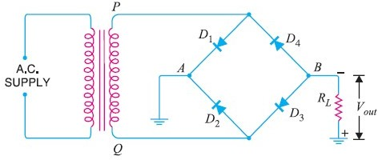**Full Wave Bridge Rectifier – Circuit Diagr**a**m**

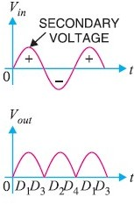**Input and Output Waveform of Full-wave Bridge Rectifier.**

**WORKING:**

The full wave bridge rectifier circuit contains four diodes D1 , D2,D3 and D4, connected to form a bridge as shown in Fig(4).

The a.c. supply to be rectified is applied to the diagonally opposite ends of the bridge through the transformer. Between other two ends of the bridge, the load resistance RL is connected.

**Operation:**

During the **positive half-cycle** of secondary voltage, the end P of the secondary winding becomes positive and end Q negative.

This makes diodes D1 and D3 forward biased while D2 and D4 are reverse biased. Hence only diodes D1 and D3 conducts.

These two diodes will be in series through the load RL as shown in Figure.

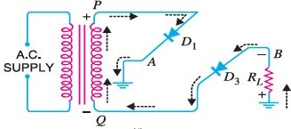

The conventional current flows through load RL is shown by the dotted arrows. It may be seen that current flows from A to B through the load RL.

During the **negative half cycle** of secondary voltage, end P becomes negative and end Q positive.

This makes diodes D2 and D4and forward biased and diodes D1 and D3 are reverse biased. Hence only diodes D2 and D4 conduct.

These two diodes will be in series through the load RL as shown in Figure.

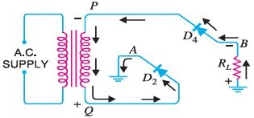

The conventional current flow through load RL is shown by the solid arrows.

It may be seen that again the current flows from A to B through the load i.e. in the same direction as for the positive half-cycle. Therefore, d.c. output is obtained across load RL.

**Peak Inverse Voltage**

The peak inverse voltage (PIV) of each diode is equal to the maximum secondary voltage of transformer i.e. Vm.

Suppose during positive half cycle of input a.c., end P of secondary is positive and end Q negative. Under such conditions, diodes D1 and D3 are forward biased while diodes D2 and D4 are reverse biased. Since the diodes are considered ideal, diodes D1 and D3 can be replaced by wires as shown in Fig. 7 (i). This circuit is the same as shown in Figure.

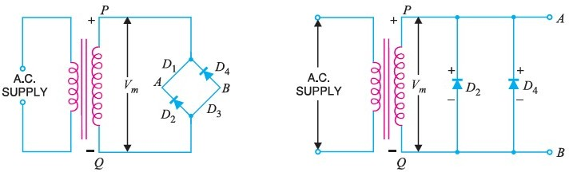

From the Figure, it is clear that two reverse biased diodes (i.e., D2 and D4) and the secondary of transformer are in parallel. Hence PIV of each diode (D2 and D4) is equal to the maximum voltage (Vm) across the secondary.Similarly, during the next half cycle, D2 and D4 are forward biased while D1 and D3 will be reverse biased. It is easy to see that reverse voltage across D1 and D3 is equal to Vm.

Hence, PIV = Vm

**Procedure:**

1. Connect the primary of center-tapped transformer to main supply. At the output points of full wave rectifier circuit, connect the vertical plates of CRO & by adjusting its knob, get a stationary pattern on the screen. Now touch the CRO probes at the center tap & one of the diodes. Observe the waves shapes on CRO compare the two wave shapes.
2. By Multimeter, measure the AC voltage at the input & output points. Also measure the dc voltage at the output point.
3. Multiply the ac input voltage by √2 to get peak value & calculate the dc voltage by Vdc = Vm / π, Compare this theoretical value with the practical value.
4. Calculate the ripple Factor by using formula.
5. Measure the PIV across the diode. It should be 2Vm.

**Observation:-** Observe the wave shape of output signal of FWR on the CRO.

**Observation Table:-**

|  |  |  |  |
| --- | --- | --- | --- |
| SR. NO. | Applied Input Voltage | Observe Output Voltage | Remark |
|  |  |  |  |

**Calculation:-**

Ripple Factor of FWR = ac voltage at o/p / dc voltage at o/p =

**Results:**

* 1. The output dc voltage is little less than the theoretical value.
  2. There is little difference between theoretical & measured value of ripple Factor.

EXPERIMENT 9

**AIM:** To study the input and output characteristics of a NPN transistor in Common Emitter (CE) configuration.

**OBJECTIVE**: To obtain input resistance find http://i.imgur.com/99B7RaO.gifVBE and http://i.imgur.com/99B7RaO.gifIB for a constant **VCE** on one of the input characteristics and output resistance find http://i.imgur.com/99B7RaO.gif**IC** and http://i.imgur.com/99B7RaO.gif**VCB** at a constant **IB.**

**THEORY:** The basic circuit diagram for studying input characteristics is shown in the circuit diagram. The input is applied between base and emitter, the output is taken between collector and emitter. Here emitter of the transistor is common to both input and output and hence the name Common Emitter Configuration.

Input characteristics are obtained between the input current and input voltage at constant output voltage. It is plotted between **VBE** and **IB** at constant **VCE** in CE configuration.

Output characteristics are obtained between the output voltage and output current at constant input current. It is plotted between **VCE** and **IC** at constant **IB** in CE configuration.

**APPARATUS REQUIRED:**

|  |  |  |  |
| --- | --- | --- | --- |
| **S. No.** | **Components/Equipments** | **Quantity** | **Remarks** |
| 1 | Transistor BC 107 | 1 |  |
| 2 | Resistors (1Khttp://i.imgur.com/6fz6IHX.gif, 100Khttp://i.imgur.com/6fz6IHX.gif) | 1 |  |
| 3 | Dual DC Regulated Power supply (0 - 30 V) | 1 |  |
| 4 | Digital Ammeters  ( 0 - 200 mA, 0 - 200 µA) | 1 |  |
| 5 | Digital Voltmeter (0 - 20V) | 1 |  |
| 6 | Connecting wires | 1 |  |
| 7 | Bread board | 1 |  |

**CIRCUIT DIAGRAM:**

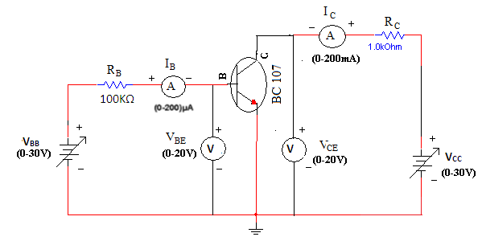

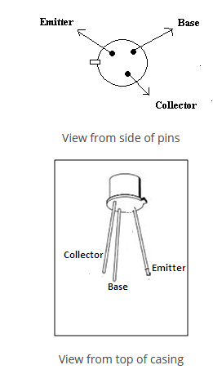

**PROCEDURE:**

**Input Characteristics:**

1. Connect the circuit as shown in the circuit diagram.
2. Keep output voltage **VCE** = 0V by varying **VCC**.
3. Varying **VBB** gradually, note down base current **IB** and base-emitter voltage **VBE**.
4. Step size is not fixed because of non linear curve. Initially vary **VBB** in steps of 0.1V. Once the current starts increasing vary **VBB** in steps of 1V up to 12V.
5. Repeat above procedure (step 3) for **VCE** = 5V.

**Output Characteristics:**

1. Connect the circuit as shown in the circuit diagram.
2. Keep emitter current **IB** = 20http://i.imgur.com/YoyOvED.gifA by varying **VBB**.
3. Varying **VCC** gradually in steps of 1V up to 12V and note down collector current **IC** and Collector-Emitter Voltage (**VCE**).
4. Repeat above procedure (step 3) for **IB** = 60µA, 0µA.

**OBSERVATIONS:**

|  |  |  |  |  |  |  |  |
| --- | --- | --- | --- | --- | --- | --- | --- |
| **Input Characteristics** | | | | | | |  |
| **VBB (Volts)** | **VCE = 0V** | | | | **VCE = 5V** | |  |
| **VBE(Volts)** | | **IB(µA)** | | **VBE(Volts)** | **IB(µA)** |  |
|  |  | |  | |  |  |  |
|  |  | |  | |  |  |  |
|  |  | |  | |  |  |  |
| **Output Characteristics** | | | | | | | |
| **VCC (Volts)** | **IB = 0 µA** | | | **IB = 20 µA** | | **IB = 40 µA** | |
| **VCE(Volts)** | **IC(mA)** | | **VCE(Volts)** | **IC(mA)** | **VCE(Volts)** | **IC(mA)** |
|  |  |  | |  |  |  |  |
|  |  |  | |  |  |  |  |
|  |  |  | |  |  |  |  |

**GRAPH:**

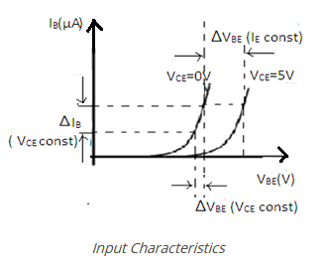

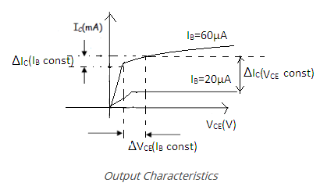

1. Plot the input characteristics by taking **VBE** on X-axis and **IB** on Y-axis at a constant **VCE** as a constant parameter.
2. Plot the output characteristics by taking **VCE** on X-axis and taking **IC** on Y-axis taking **IB** as a constant parameter.

**KEY PARAMETERS:**

* Max Collector Current = 0.1A
* VCEO max = 50V

**EXPERIMENT RESULT:**

1. Calculate the ideal voltages and currents for each element in the circuit and compare them to the measured values.
2. Compute the percentage error in the two measurements and provide a brief explanation for the error.
3. Give the explanation regarding the error in terms of different causes etc.
4. Explain the behavior of the graph and why it is so?

**PRECAUTIONS:**

1. While performing the experiment do not exceed the ratings of the transistor. This may lead to damage the transistor.
2. Connect voltmeter and ammeter in correct polarities as shown in the circuit diagram.
3. Do not switch ON the power supply unless you have checked the circuit connections as per the circuit diagram.
4. Make sure while selecting the emitter, base and collector terminals of the transistor.

**QUESTIONS:**

1. Can transistor be replaced by two back to back connected diodes?
2. For amplification CE is preferred, why?
3. What is the range β of a BJT?

CONCLUSIONS

After completion of basic electrical and electronics lab, students are able to

* Handle of basic electrical and electronics equipment’s
* Do staircase wiring on bread board.
* Understand domestic wiring procedures.
* Analyze KCL and KVL in any circuit.
* Simplify the circuits using Thevenin and Norton theorem.
* Analyze and draw the characteristics of PN diode, Zener diode, BJT in common base emitter.

PROBLEM STATEMENTS

* According to the passive sign convention, power assumes a positive sign when the current enters the positive polarity of the voltage across an element.
* Two elements are in series when they are connected sequentially, end to end. When elements are in series, the same current flows through them. They are in parallel if they are connected to the same two nodes. Elements in parallel always have the same voltage across them.
* Source transformation is a procedure for transforming a voltage source in series with a resistor to a current source in parallel with a resistor, or vice versa.
* The efficiency is only 50% when maximum power transfer is achieved, but approaches 100% as the load resistance approaches infinity, though the total power level tends towards zero. Efficiency also approaches 100% if the source resistance approaches zero, and 0% if the load resistance approaches zero.
* Silicon diodes have a forward voltage of approximately 0.7 volts. Germanium diodes have a forward voltage of approximately 0.3 volts. The maximum reverse-bias voltage that a diode can withstand without “breaking down” is called the Peak Inverse Voltage, or PIV rating.
* If the turns ratio is equal to unity, n = 1 then both the primary and secondary have the same number of windings, therefore the voltages and currents are the same for both windings.

Statement of Mini Projects

* Verification of KCL and KVL in the presence of resistive circuit, resistive and inductive circuit with AC supply source.

Do and Don’ts

* Avoid contact with energized electrical circuits.
* Powered equipment can be hot! Use caution when handling equipment after it has been operating.
* Select proper type of supply (i.e. a. c. or d. c.) and range of meters.
* All the connections should be tight.
* Never exceed the permissible values of current, voltage, and apparatus, wire, load, etc.
* If water or a chemical is spilled onto equipment, shut off power at the main switch or circuit breaker and unplug the equipment.
* Be sure you understand the function and wiring of an instrument before using it in a circuit.